
Programming 1
BACT7501

ASSIGNMENT – 2

Software Development Project
- Name – Patel Meet Nagjibhai
- Student id - 20260261
- Subject – Information Technology Fundamentals
- Subject code – BACT7502
- Date – 01/07/2026

1 – Creating a New GitHub Repository

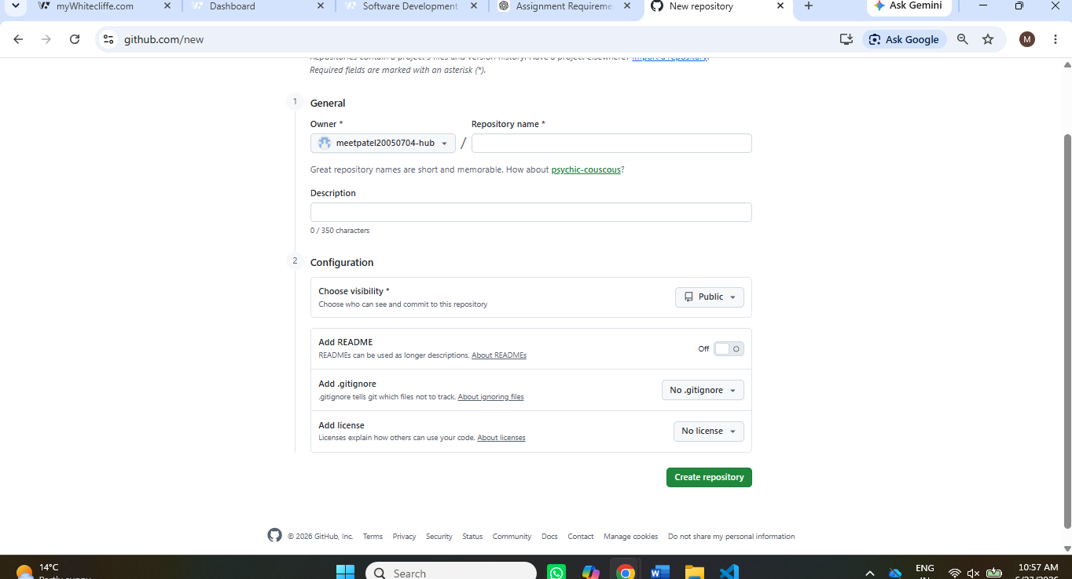

This is a screenshot of creating a new repository on GitHub for the Requisition System project. In this step, I typed the name of the repository "requisition-system" and short description about the project. I chose a visibility of Public and enabled the README option so it will contain a simple project documentation. It is important that the creation of the repository is a first step because it allows to have all the necessary project files, future changes, documentation and source code in one central Web space. It also sets up the project for version control via Git and GitHub.

2 – Repository Successfully Created
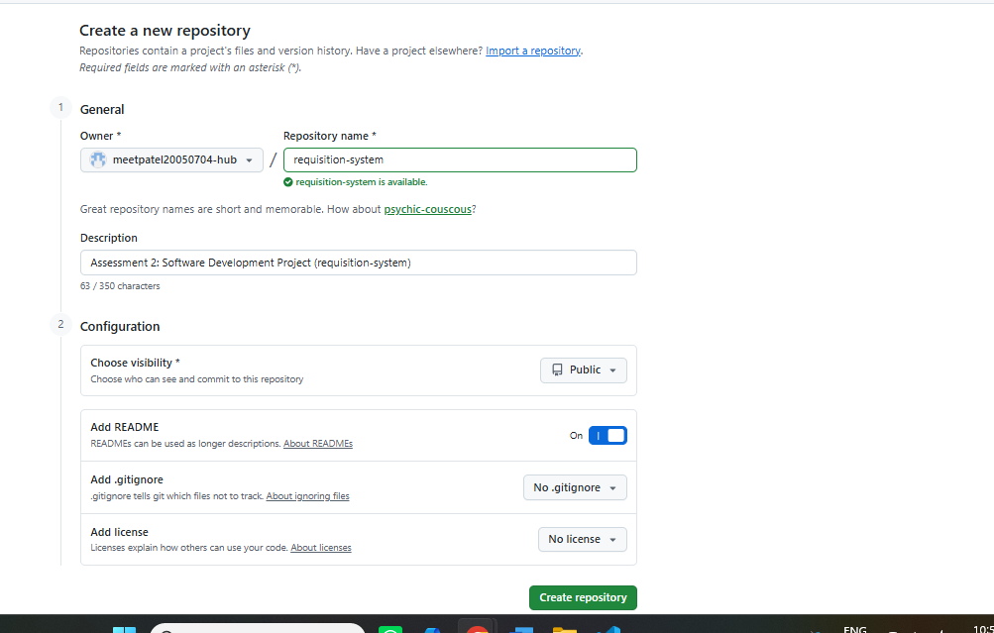

This screenshot shows the GitHub repository after it was successfully created. The README.md file is now in the repository and the first commit added by GitHub. The repository page also shows some key information, like the repository name, description, default branch and useful navigation options like Code, Issues, Pull Requests and Actions. If the repository is created successfully, it means that the remote location where the project files will be stored is ready. The whole development process of this project will be stored in this repository and the backup will be conducted online during the software development process.

3 – Checking Git Repository Status
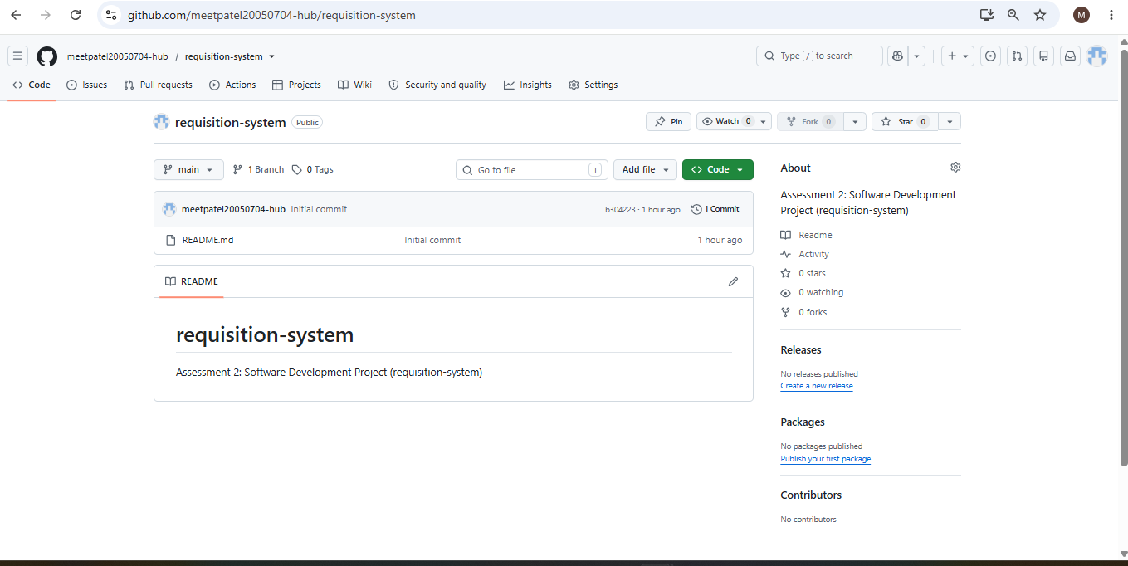

The following is a screenshot of Visual Studio Code using the git status command. The command prints information about the current state of the local repository, showing which files are modified, deleted, and untracked. This is crucial because this enables the developer to see all the changes in the project before he/she pushes them to the repository. I could see which files were in the repository and which were not and could stage and commit those that were not. To prevent the unintended commit of files, and to let only intended files into each version of the software project, git status is used on a regular basis.

4 – Initializing Git and Adding Remote Repository
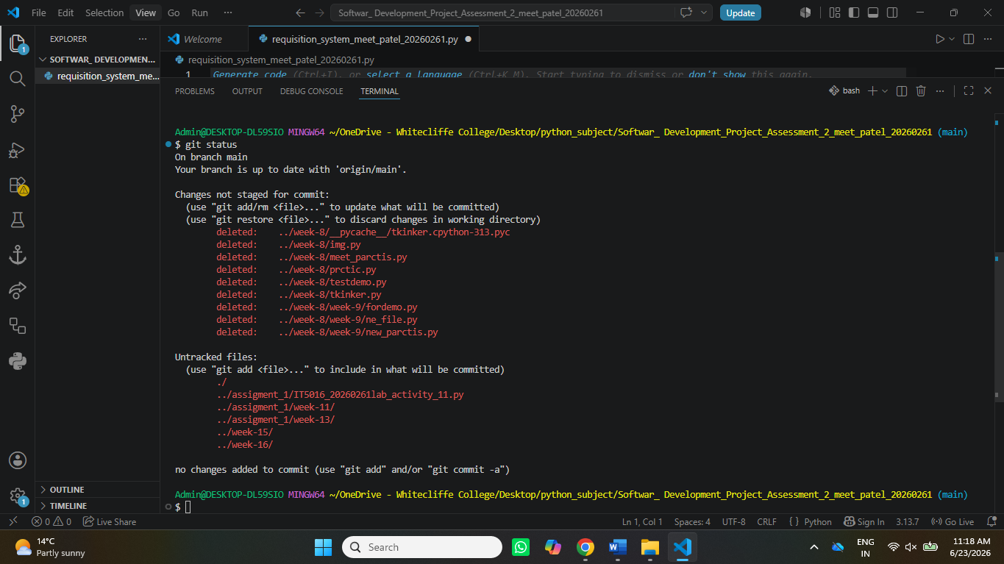

This is a screen shot of starting Git and linking up the local project to the GitHub project. I initially ran the git in it command to set up a local repository with git. I then tried to add remote URL to the repository with the git remote add origin command, but it failed. The first error was due to the wrong syntax of the command. I checked the error message, fixed the command and was able to connect the local project to GitHub. In this process, you will learn the significance of debugging command line problems and how to ensure the local and remote repository are properly connected before uploading files.

5 – Verifying the Remote Repository
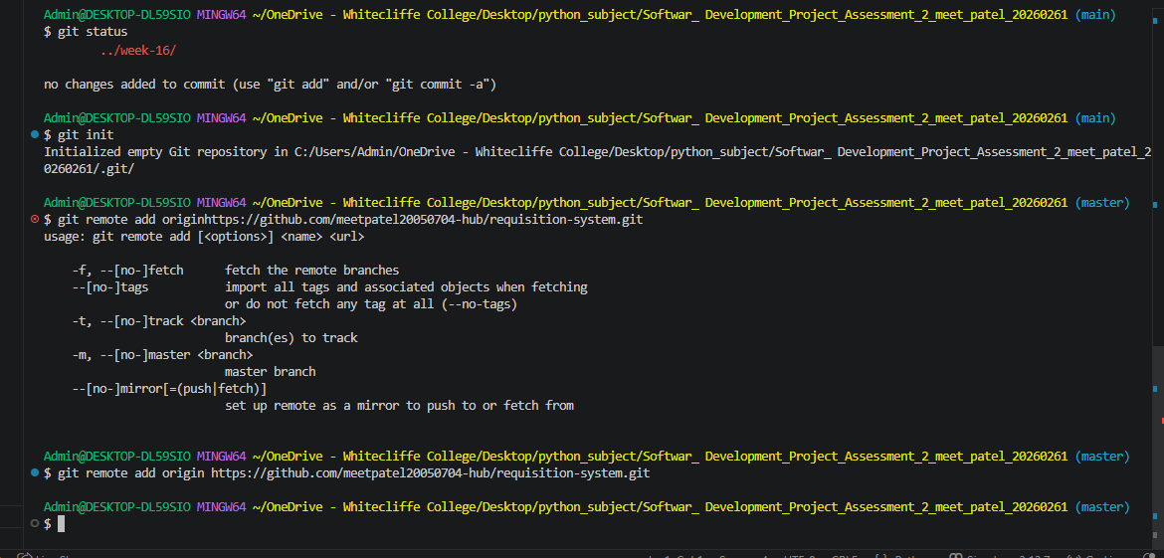
The result of running the git remote -v command is displayed, indicating that the remote repository on GitHub has been verified. The command prints out both the fetch and push URL of the GitHub repository. It is important to verify the remote connection as this will verify that the local project is connected to the right online repository. This prevents files from being uploaded onto the wrong project, and also allows for later git operations like git push and git pull to talk to the right remote repository. This verification is successful and it confirms that the Git configuration has been done successfully.

6 – Creating the First Commit
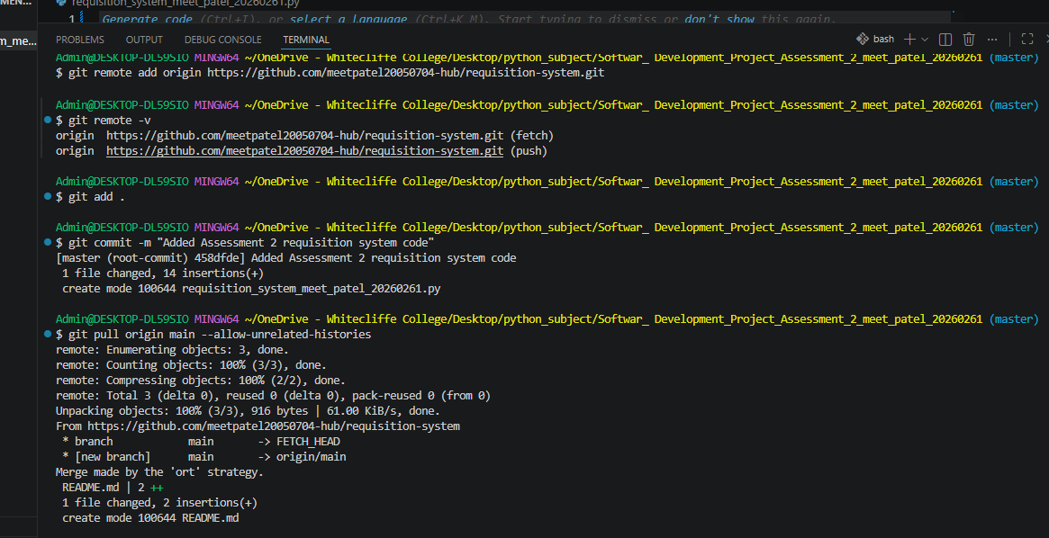
This is a screen shot of staging and committing of Requisition System project. The git add . command stages everything that was changed in the project, which is ready to be put into version control. Once the files were staged, I used the git commit command with a descriptive commit message that details the changes I performed. A commit is a point in the project's development where it is in a stable state. Commit messages that are easily understandable usually indicate the progress of the project and what differences have been made in each version. Commits are a crucial component in maintaining a structured version history.

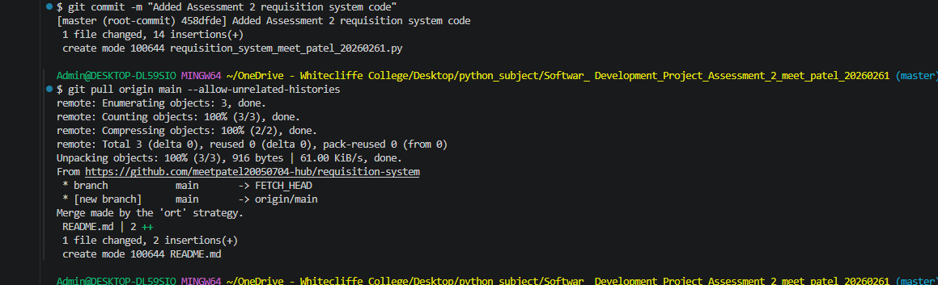

7 – Pulling Changes from GitHub
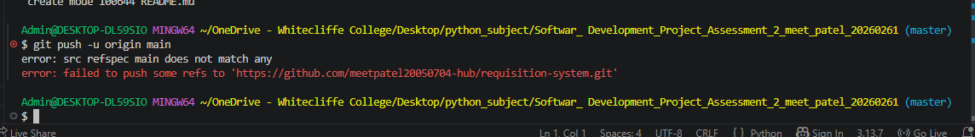
The following is a screen shot of the execution of the command "git pull origin master --allow-unrelated-histories". This command had to be used since there was already a README file in the GitHub repository, and the project files were in the local repository. The changes on the remote system were downloaded and merged with the local project successfully. Using the --allow-unrelated-histories option allowed Git to combine two repositories that were created independently. This step was taken so that the same history of a project will exist in both the local and remote repository prior to uploading the Python application to GitHub.

8 – Renaming the Branch

This screenshot shows the use of the git branch -M main command. At first the local Git repository was called master and the default branch in GitHub was called main. Due to this mismatch, the project could not be uploaded successfully. The problem was resolved by renaming the branch, which made both repositories have the same branch name. This step shows that you understand git branch management and you know the significance of having consistent branch names in local and remote repository. After renaming the branch, the project was ready to be uploaded successfully.

9 – Uploading the Project to GitHub
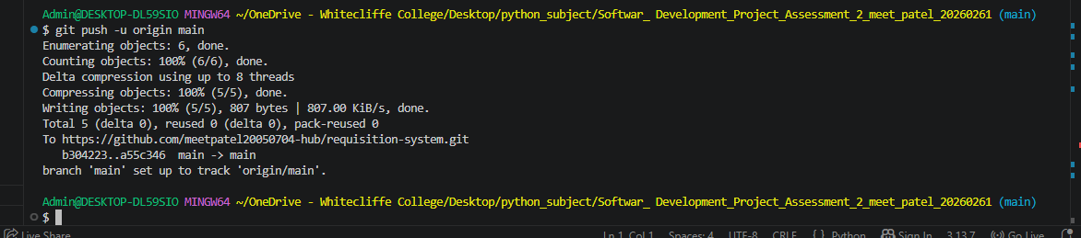
This is a screen shot of the successful run of the git push -u origin main command. This command uploaded the entire project Requisition System to the GitHub repository from the local computer. The terminal returns a message stating all the project files were transferred successfully and local main branch is now tracking the remote main branch. Having branch tracking made updating easier for future updates as only git push is needed to upload new changes. This will finish the link between the local project and the online GitHub repository.

10 – Final GitHub Repository
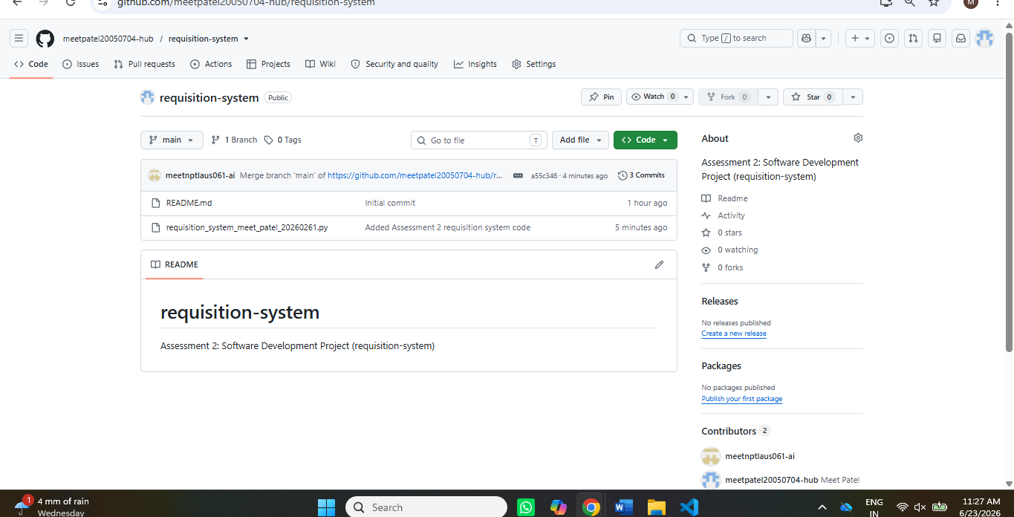
This is the screenshot of the successfully uploaded Python project in GitHub. The Requisition System source files, the README and commit history during development are now stored in the repository. The repository is a secure online backup and a successful example of the use of a version control system called git. It also provides a complete history of the software development process, making future updates and maintenance easier. Hosting the project on GitHub adheres to good software development principles, and allows the project to be accessed, reviewed and shared as needed.
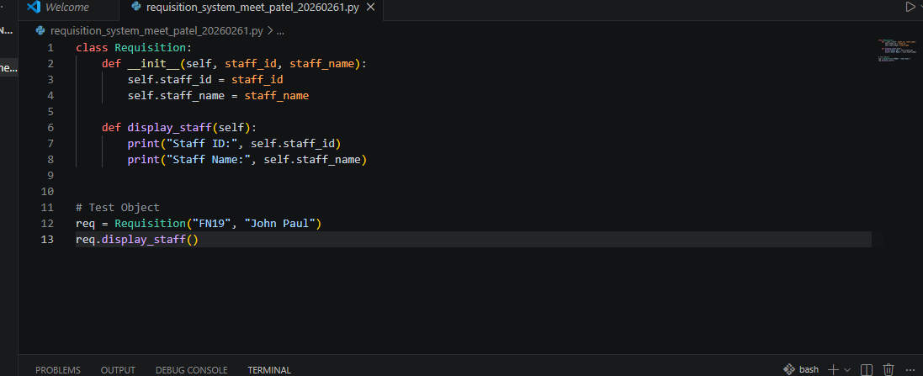

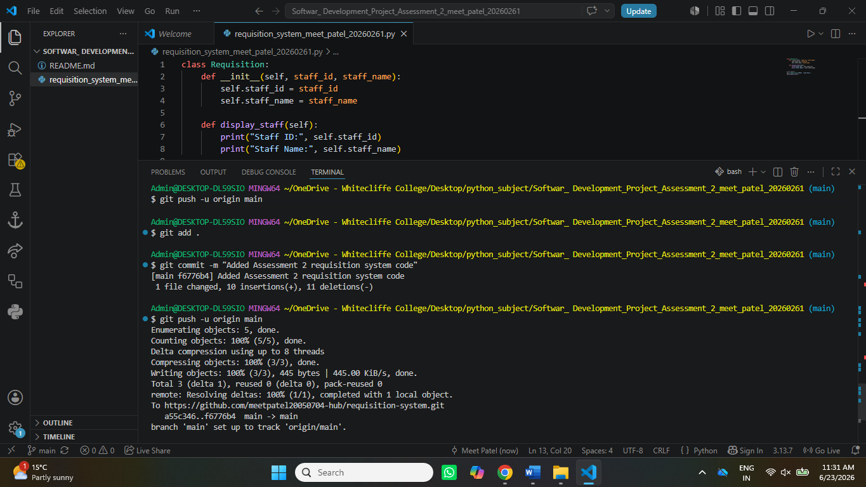

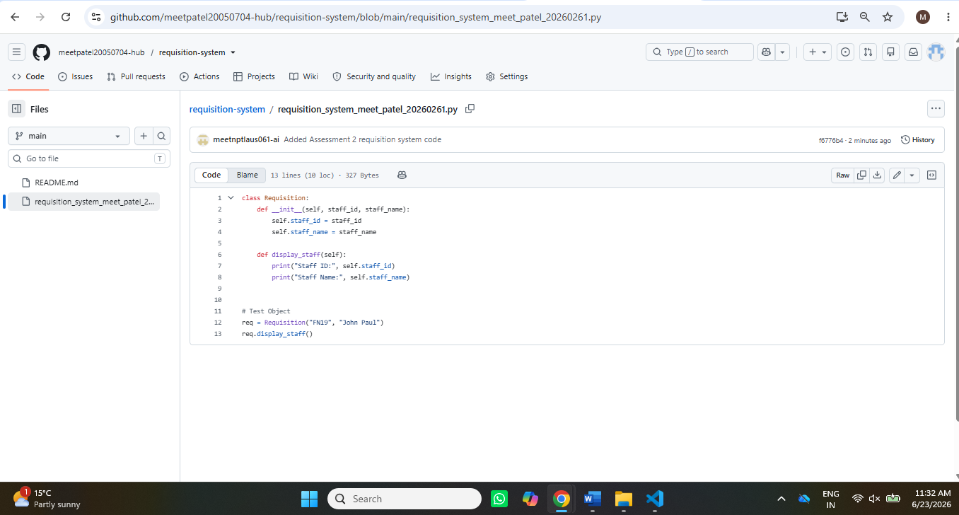

- First error
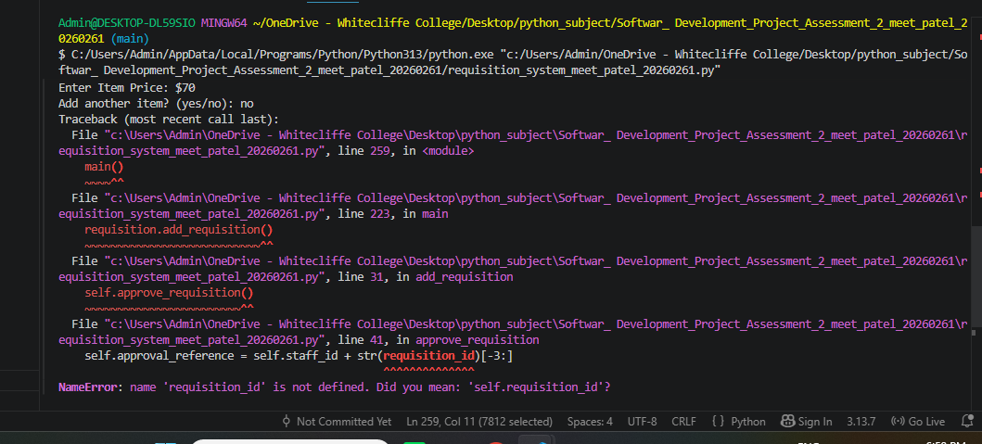
- First error in code before fix it

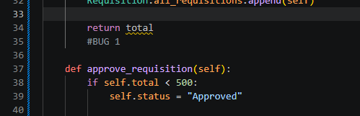
- First error in code after fix it.
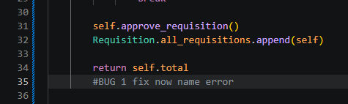

1 – Name Error (Undefined Variable): Exception Trace:
Error Type: Name Error
Location: approve requisition() method.
Type Error: object has no attribute requisition_id.Oops, that object has been modified and doesn't have the attribute requisition anymore.
The error, Reason for Error: requisition was not defined as a local or global variable, means that the requisition variable is not defined anywhere. It is an instance attribute, which needs to be retrieved with the self-keyword.
Traceback (most recent call last): Line 4, in send_requisition_data yahooobj.requisition_id = data Line 4, in send_requisition_data Name Error: name not defined
How I figured out what it was: I read the Python traceback, and it gave me the exact file, line, and method that the error occurred in.
Problem: Requisition is incorrect. Solution: Changed requisition to self.requisition_id.
Solution: The error has been addressed and the program ran as intended, without interruption, creating the required approval reference number.

2)
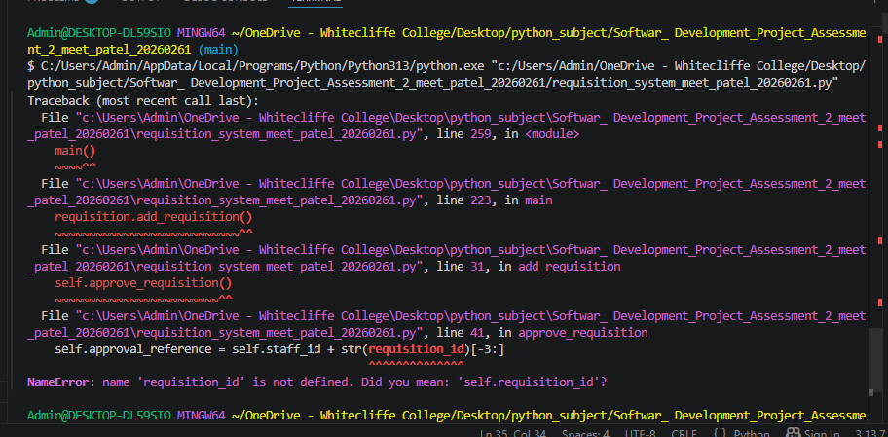
2)
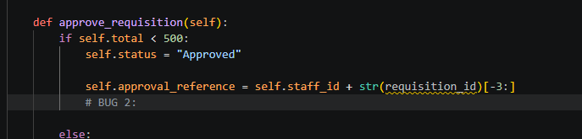

2)fix bug
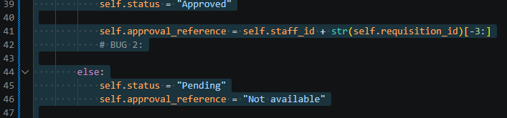

Bug 2 – NameError (80 Words)
Error Type: NameError.
Location: approve_requisition() method.
The code was incorrect because it referred to requisition_id but it should have been referring to self.requisition_id.
However, if the object is an instance attribute, you'll get an error message: The program was stopped because the variable requisition_id was not found in python.
Solution: Changed the requisition_id to self.requisition_id.
Resolution: The approval reference number was generated correctly after fixing the code and the requisition approval process was run successfully with no run time error.

3)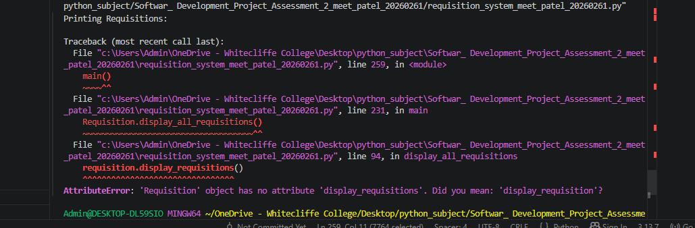

3)
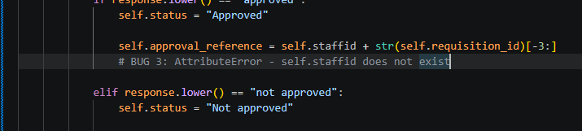
3)


3 – AttributeError (80 Words)
Error Type: AttributeError.
Location: respond_requisition() method.
The code tried to use an attribute "self.staffid", that hasn't been defined in the Requisition class.
TypeError: 'NoneType' object has no attribute 'staff_id' is raised because the attribute staff_id is not found.Reason: It is raised because the attribute staff_id is not found, it was created in the constructor (__init__). Python threw an AttributeError, due to the wrong attribute name.
Solution: I changed my code to fix the error, which was self.staffid to self.staff_id.
Success: The approval reference number was created correctly, and the process for getting the manager response was performed successfully with no run-time errors.

4)
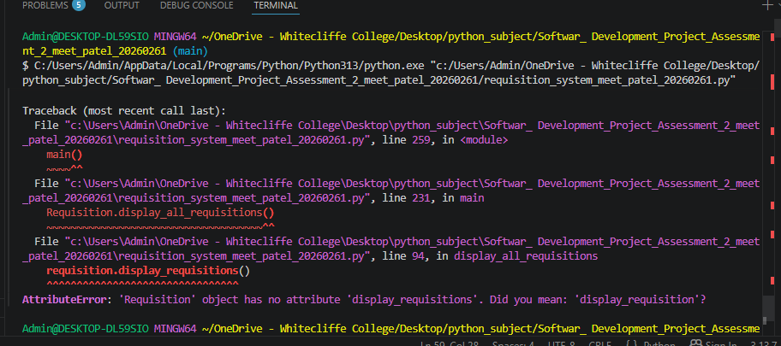

Before fix
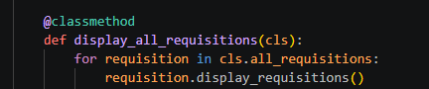
Fix
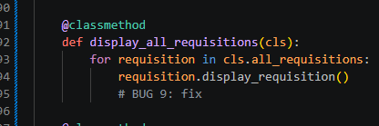

Bug 4 – AttributeError (80 Words)
Error Type: AttributeError.
Location: display_all_requisitions() method.
Message: display_requisitions(), called function did not exist in class Requisition.
The error details: Reason: The method name was not found: display_requisition (). Python encountered an attribute error, display_requisitions(), because it didn't have that method.
Solution: I fixed the method call, which was to display_requisitions(), to display_requision().
Outcome: All the requisition details were successfully displayed without any run time errors with the corrected method name.

5)
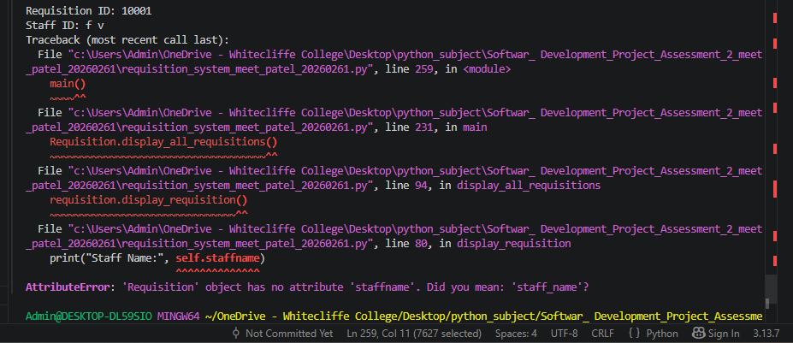
5) before

5) fix
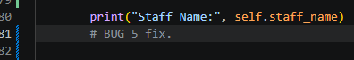
Bug 5 – AttributeError (80 Words)
Error Type: AttributeError.
Location: display_requisition() method.
NameError error in call to self.staffname: The code tried to use self.staffname, but it wasn't defined in the class Requisition.
The problem here is that the attribute does not exist in the constructor. The name of the attributes is case-sensitive and spelling-sensitive, and if you didn't specify the correct name it resulted in an AttributeError.
The problem was that I had self.staffname and I replaced it with self.staff_name.
Result: The staff name has been corrected and after that, the name of the staff was printed correctly and there were no runtime errors for printing the requisition details.

6)
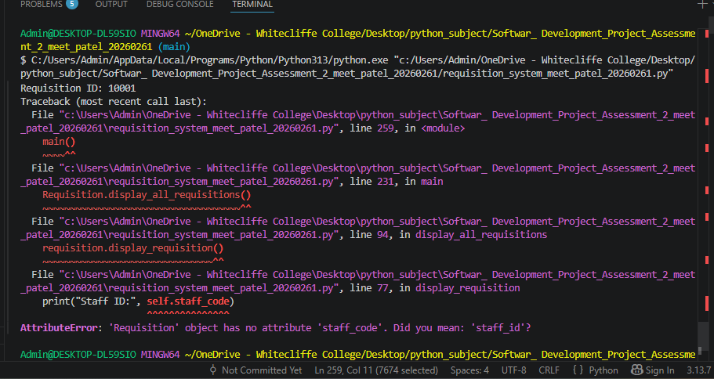
6) before fix:
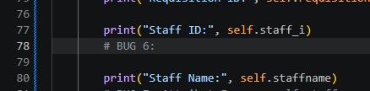
6) fix
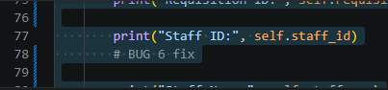
Bug 6 – AttributeError (80 Words)
Error Type: AttributeError.
Location: display_requisition() method.
A problem was found: The code tried to use self.staff_code, but the class Requisition does not contain an attribute named staff_code.
The attribute "self.staff_id" was not found in the constructor. Python threw an AttributeError as staff_code was not found.
The problem: I had self.staff_code, I changed it to self.staff_id.
The result: Staff ID was shown correctly and there were no runtime errors when the requisition details were printed.
7)
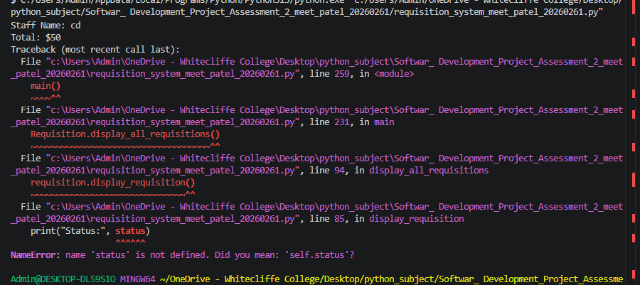
7)
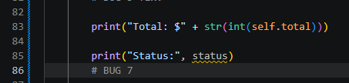
7)
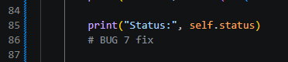

Bug 7 – NameError (80 Words)
Error Type: NameError.
Location: display_requisition() method.
Error: The code was supposed to print status but instead, self.status was printed.
Explanation: status is an instance attribute that has been created in the constructor, therefore it must be accessed through the use of the self keyword. However, Python did not have a scope in which the variable status was defined, so it threw a NameError and ended the program.
I changed the word status to self.status in solution.
Result: The outcome showed that the requisition status changed to correct after it was corrected, and there were no runtime errors after executing the program.

8)
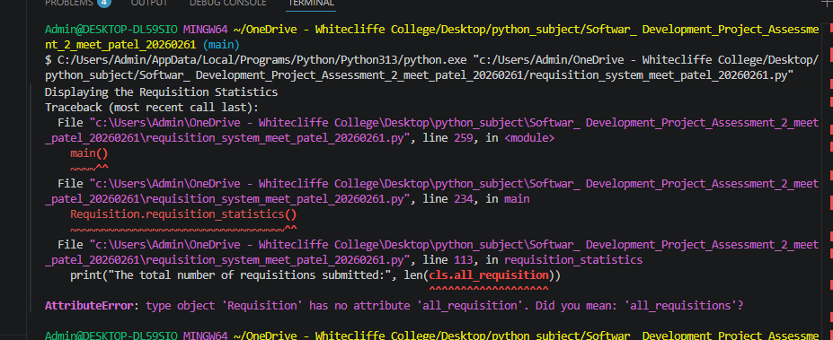

8)

8)
Bug 8 – AttributeError (80 Words)
Error Type: AttributeError.
Location: requisition_statistics() method.
Error: The code called cls.all_requisition but there was a problem, because it did not exist in the class.
Explanation: You have declared a class variable, all_requisitions, ending with an 's'. Due to the wrong attribute name, Python was not able to find the attribute, and thus threw an exception called AttributeError.
Solution: I changed the name of cls.all_requisition to cls.all_requisitions.
Outcome: The class attribute name was corrected and then the number of requisitions required was calculated and displayed without any runtime errors.

9)
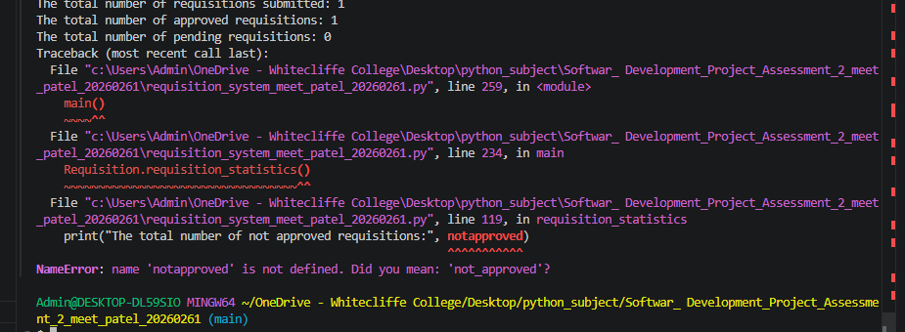

9)
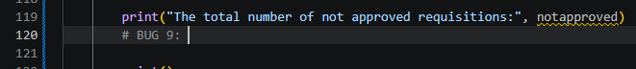
9)
Bug 9 – NameError (80 Words)
Error Type: NameError.
Location: requisition_statistics() method.
The variable notapproved was not defined in the code.
Problem: The name of the variable declared earlier in the method was not_approved. The name was incorrectly spelled and missing the underscore, so Python did not recognize it, resulting in the NameError error.
Solution: I changed the variable name from notapproved to not_approved.
Result: Once corrected, the program ran successfully without any runtime errors, and the final output of the number of not approved requisitions was correct.
10)
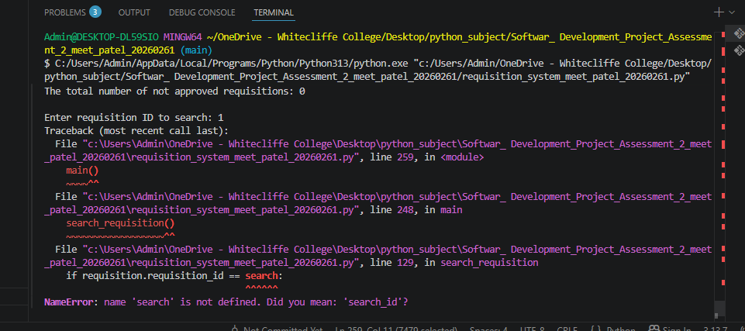
10)
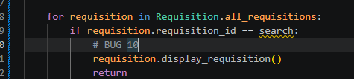
10)\
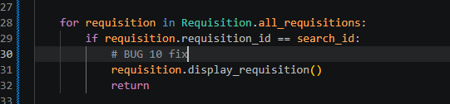

Bug 10 – NameError (80 Words)
Error Type: NameError.
Location: search_requisition() method.
The code was comparing the requisition ID with search but this variable was not defined.
Error: The value of the variable search was not obtained from the user, but rather was stored in search_id. The program had a NameError when Python was unable to find the variable search.
I changed search to search_id in the comparison, thus fixing the problem.
Outcome: Fixing the variable name, the search function found and displayed the requested requisition without runtime errors.

11)
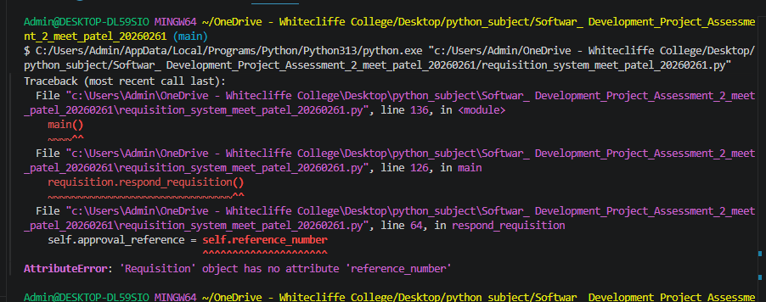

11)
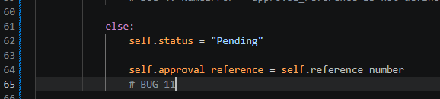
11)
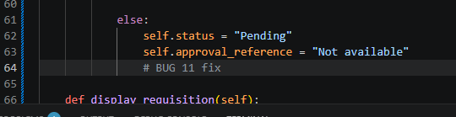

Bug 11 – AttributeError (80 Words)
Error Type: AttributeError.
Location: respond_requisition() method.
However, there was a problem with the code: It tried to get the attribute self.reference_number, but the attribute was not found in the Requisition class.
The attribute that was used in the program is incorrect (self.approval_reference). Python threw an AttributeError because reference_number wasn't created in the constructor.
Solution: self.reference_number was changed to “Not available”.
Outcome: After fixing the code, pending requisitions kept the approval reference as Not available, and the manager response section executed successfully.

12)
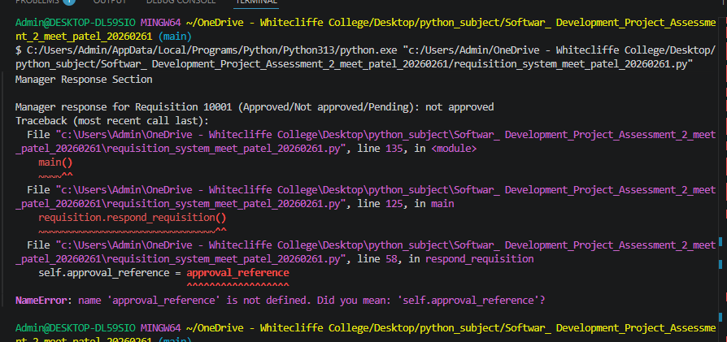

12)
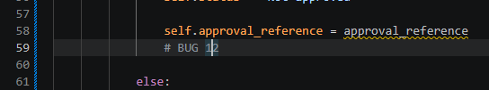

12)
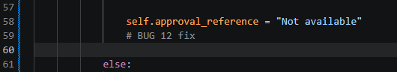
Bug 12 – NameError (80 Words)
Error Type: NameError.
Location: respond_requisition() method.
TypeError: object attribute 'approval_reference' has not been found.The line was there to assign approval_reference to self.approval_reference, but approval_reference was not defined.
Error: Variable ‘reason’ has not been declared. Python encountered a NameError when trying to find the name 'approval_reference'.Python found no approval_reference in its name space and stopped.
Solution: I changed that value to "Not available" - it should be replaced with the correct value.
Rejected requisitions were shown as "Not available" as the approval reference, and there were no runtime errors during the manager response process after fixing the code.

Software Development Lifecycle

1. Planning
The planning stage was the initial and one of the most significant stages in the evolution of the Requisition System. To ensure that the software meets the assessment requirements, I studied the requirements carefully so that I can understand what the software should do and how it should work before writing any Python code. For the assessment, a requisition management system, using Object Oriented Programming (OOP), had to be developed such that staff members can submit a requisition request, a requisition can be automatically approved if it is eligible, staff members can view the status of any pending request, and overall statistics on the system of requisitions can be displayed. By knowing these requirements beforehand, there was less confusion when developing the project and it was easy to have a direction for the project.
In the design phase, I first came up with the general goal of the application. The main motivation was to automate the manual requisition process by creating an easy-to-use console program to process the requisition. I wanted the application to be able to calculate the total amount of a requisition and to determine if the requisition should be approved or not, and to create an approval reference number if it would be approved; and I wanted to reduce as much as possible the number of manual calculations that would be required within the application. The automation of such repetitive tasks would help to streamline the process and minimize the risk of human error.
The other significant task in this stage was to come up with the plan for the program. I chose to use Object Oriented Programming (OOP) instead of a single long one with all procedures in order to be able to group together related data and functions within a single class. So, I'd decided to make a single class Requisition, and have each Requisition be an object. This makes it easier to read, maintain and enhance the code to improve the program in the future without major changes to code.
I also designed the data to be stored with each requisition object. Each requisition will have its own requisition ID, date submitted, staff ID number, staff name, total requisition amount, approval status and approval reference number. The following properties were later added to the constructor of the class `Requisition` (the name for the request). I wanted to make sure that every requisition that was requisitioned had its own unique ID number, so I was going to use a class variable called `requisition counter`; this variable increments every time a new object of the `Requisition` class is created.
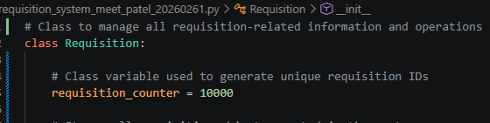
I also thought of how I would store multiple requisitions during the program run time. I didn't want to use multiple variables to store information; instead, a class list called all_requisitions would be created. This list would be updated on a frequent basis with each new requisition object so that after the data entry process there would be a summary of all the requisitions.
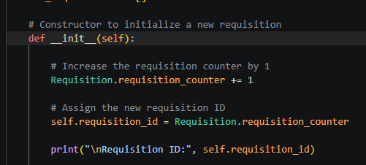
During this phase, business rules to approve requisitions were also set. As per the assessment requirements, if the total value of the requisitions is below $500 then the requisitions should be automatically approved; if the total value of the requisitions is $500 or above, then the requisitions should be pending until they are reviewed by a manager. The planning of these rules prior to implementation resulted in a simple, consistent and easy to implement approval process in the method `approve_requisition()`.
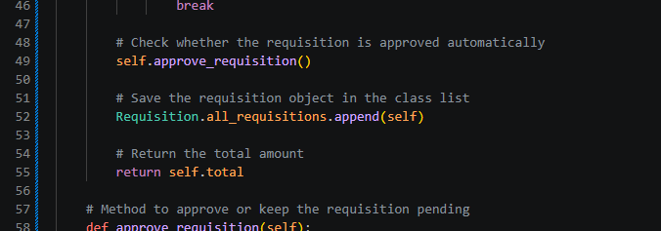
Last but not least, I designed the general flow of the program. It would first take in the information of employees, and then it would take in several items to be ordered and the prices of the items. Once the total is calculated, it would display the total, store the requisition object in a database, show all the requisitions, enable managers to action pending requisitions, and then generate a summary of statistics. Preplanning this sequence before coding reduced development time and aided in the development of a sequence to meet all assessment requirements.

During the Planning phase, the following activities are completed:

Carefully analyzed the assessment requirements.
Determined the goal and aims of the requisition system.
Intended to use Object Oriented Programming.
Wrote the design of the class `Requisition` first, and then implemented it.
Determined all the necessary attributes and methods.
Was going to employ the `requisition_counter` for unique IDs.
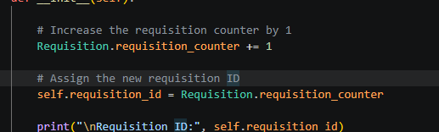
* Planned to use `all_requisitions` to store all requisition objects.
Approved a rule that states that the variable $500 must be less than $2000.
Initiated the application overall process: Data Entry to Statistical Reporting.

Screenshot

1 – “class Requisition”
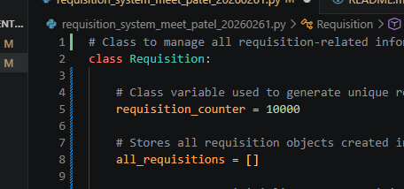

2 – “__init__()` constructor with the attributes.”
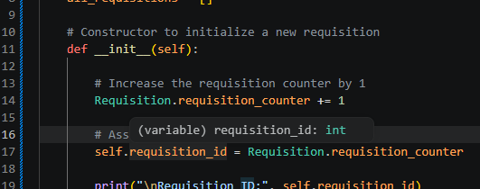

3 – “All requisition (all_requisitions) and requisition counter (requisition_counter) class variables.”
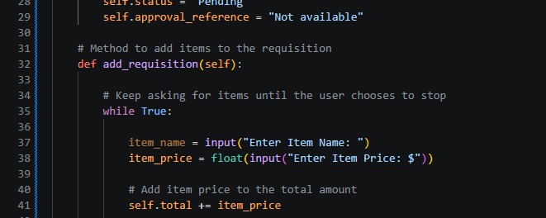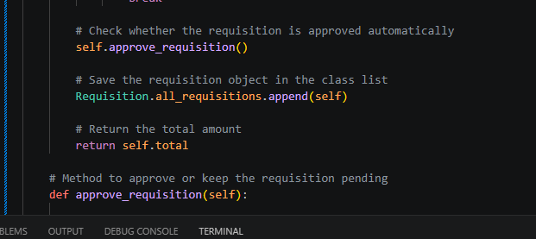

2. Requirements Analysis
Once the planning stage was over the next step was to analyses the detailed requirements of software. This stage was to determine what information the program would require, how the information will be processed, and the output of the system. The analysis was performed before coding the majority of the code ensures that all the functional requirements outlined in the assessment were mapped out in the final application.

As part of the analysis, the first task was to determine the input(s) needed. The application had to request some data from the user such as the date of a requisition, the identification number of a staff, his/her name, the names of items required, and the price for each item requested. Because there can be more than one item on a requisition, I also investigated how the user would enter the information for each item until the required information was entered on the requisition. This later led to the inclusion of a `while True` loop within the `add requisition ()` function.

Once the inputs were determined, I did the processing which needs to take place in the application. After user entered all item prices, the system had to add all of the item prices entered to get the total requisition value. This has been done by using the line "self. Total += item price", which will update the total amount of money every time an item is added. After the final total was arrived at, the application should be compared to the business rule to see whether the requisition should be approved automatically or not be approved and remain pending.
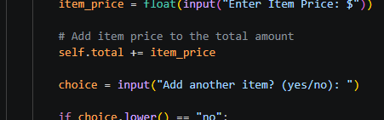

Another vital step in the analysis process was to get approval. I found that approved requisitions should have an approval reference number, which I came up with to be the staff ID followed by the last 3 digits of the requisition ID number. That was later changed to be part of the approve requisition () method. If the request is over the approval limit, the approval reference could not be seen until the manager has approved the request.
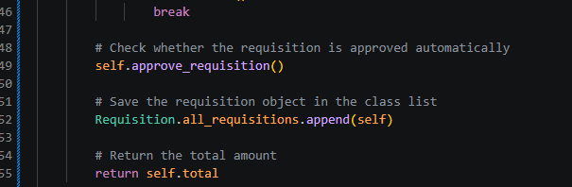
A significant requirement that was found during this stage was to store all requisition objects, so they can be displayed once data entry is completed. Each requisition object is stored in the class list `all requisitions`, instead of printing info right away. This design can display all requisitions at a time and provide stats indicating the number of approved, pending and rejected requests.
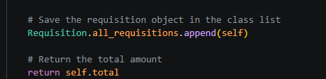
The required outputs of the system were also analyzed. The application required to show individual requisition information, status of approval, reference numbers of approvals and summary statistics. The outputs were realized by the 'display requisition ()', 'display_all_requisition()' and 'requisition statistics()' methods. Finally, the manager should be able to select Approved, Not Approved and Pending to update the pending requisitions. This was accomplished by using the `respond requisition ()` method.
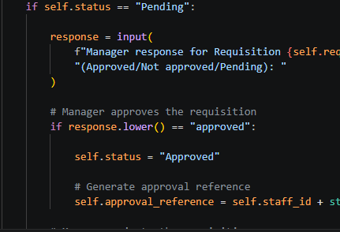
By analyzing these requirements prior to implementation, the inputs, processing, outputs and business rules of the program were understood and the development stage was more organized, with the requirement of a lesser number of design changes in the later stage.

During the analysis, the following requirements are identified: The following requirements are found during analysis:

Record the date of requisition, staff member's ID and staff member's name.
Be able to accept several items and prices on a requisition.
Automatically calculate total amount of requisition.
Create a new ID for each request.
Accept requests less than $500.
Enable Manager responses on pending requisitions.
Generate approval reference numbers.
Keep all the objects required for the requisition in a class list.
Present reports and summary statistics for requisition.

3. Solution Design
After analyzing the project requirements, the next phase was the phase of solution design. This part of the process involved designing the operation of the software prior to the coding stage. It's a good software design if it allows the developer to organize its code, lessen its complexity, make it more readable, and easier to maintain in the future. In this stage I translated the software requirements into logical program structure which is later implemented in Python.
Having analyzed the requirements, I concluded to create the application using Object Oriented Programming (OOP), as it will be able to group the data and functions into one re-usable class. Rather than writing one big procedural program I wrote a class named Requisition which represented each of the requisition forms that a member of staff would make. A new object of the Requisition class is created each time a new requisition is created. This design allows for better organization of the code as each requisition contains its own information, but has shared methods.

The first step in the design was to decide on the characteristics that are needed for each requisition. From the requirements analysis, all the requisition objects had to hold the requisition ID, date, staff ID, staff name, total amount, approval status and approval reference number. These attributes were added to the `__init__()` constructor to ensure that they will always be created when a new requisition object is created.
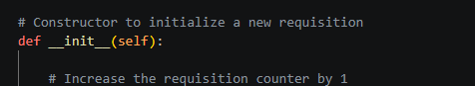

I created two significant class variables, too. The first one of the variables, `requisition counter`, is automatically provided with a new number for each new requisition. This will prevent duplicate IDs and will allow each requisition to be uniquely identified. The second-class variable, all requisitions, holds all of the requisition objects that are created during the course of the running of the program. By using one list, it is possible to view all the requisitions and, later in the program, to provide summary statistics.

An additional design decision was to break up the application into multiple methods, each having a single responsibility. I reduced the program logic into individual methods rather than being all contained in one. The `add requisition () method was added to gather information about the items and to total up the amounts. The `approve requisition () method was created in an effort to apply the business rules and determine if the requisition will be automatically approved. The managers can check and update status of pending requisitions by calling the ‘respond requisition () method. Lastly, `display requisition () display_all_requisitions()` and `requisition statistics()` were developed to display requisition information and summary reports.
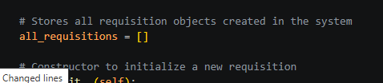
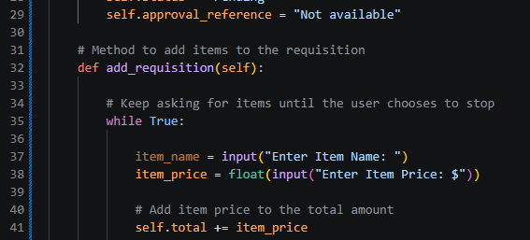
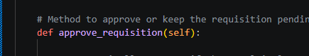
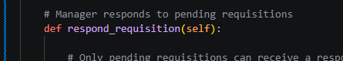
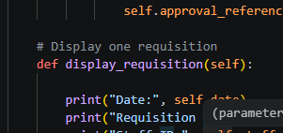
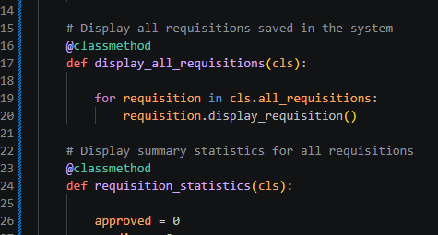

Each method has only one specific task performed, making it a good programming practice. If any changes are needed in the future, the developer can change any of the methods without impacting the other parts of the program. This will make your program easier to maintain and keep debugging.

The layout of the user interface was deliberately made very simple, so as to be an application of the console type. Because the program is not about using a graphical user interface, it talks to the user from the terminal through the use of the `input()` and `print()` functions in Python, and is designed to evaluate Python programming and object-oriented concepts. This simple interface enables the user to easily input information, while still maintaining the simplicity and understandability of the program.

Design decisions implemented
- Utilized Object Oriented Programming to enhance organization.
- Written a single class for handling all of the requisition data, called Requisition.
- Designed classes with variables that are common.
- Used the constructor, `__init__()`, to initialize all the requisition.
- Differentiated the program to include several methods with specific tasks.
- Designed an easy-to-use Terminal based User Interface.
- Developed alternative ways of reporting and providing statistics.

4. Implementation
The implementation phase was when the planned software design was translated into software code written in Python. This stage was the longest of the project due to the implementation of all of the planned features while fulfilling the requirements of the assessment. While implementing, I used the same design that I designed in the phase before and slowly developed the application step by step.

The first task was to make up the class **Requisition** and the constructor `__init__()`. Each new requisition object automatically has a unique ID, since it increments the `requisition counter` class variable. The constructor also saves the date of the requisition, the staff number and the name of the staff who enters the requisition. The total amount, approval status and approval reference number are also assigned the default values when creating the object. It is convenient to set these attributes in the constructor, so that all requisition objects have the same initial values.
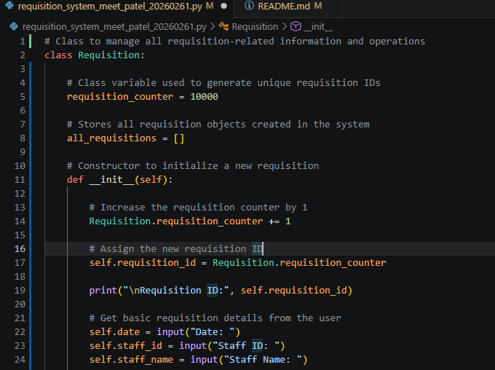

The next step in implementation was to create the `add_requisition()` method. The users can enter multiple requisition items by this method. A `while True` loop is used to repeatedly prompt the user for item names and prices until the user decides to not enter any more items. Each item price that the user enters is added to self.total with the statement `self.total += item_price. This implementation will calculate the total value of the requisition which doesn't require extra calculations when data is entered.
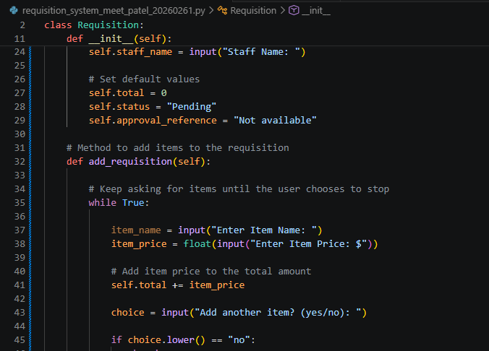

Once all items have been added, the `approve_requisition()` method is automatically called. This approach is comparing the total values that were required, to the business rule that was defined in the planning phase. If the total amount is under or equal to $500, the requisition status is changed to Approved and an approval reference number is automatically created that is composed of the staff ID and the last three digits of the requisition ID. If the total amount of money is $500 or more, the requisition is marked Pending and the manager can make the final decision later.
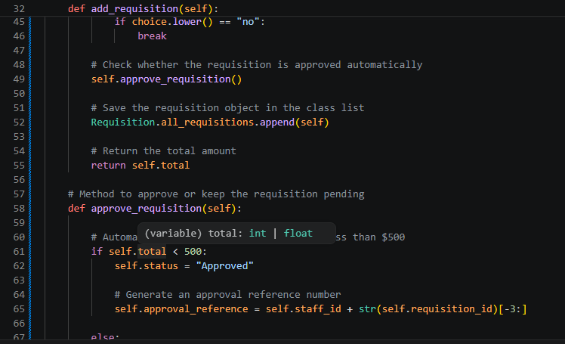

I added the `respond_requisition()` method to aid in the manager's decision making. This is only run when a requisition is pending. The manager may input the status of Approved, Not Approved, or Pending; the program automatically updates the requisition status. If the reference number is approved, the process will create a reference number. If denied or not yet approved, the approval reference isn't displayed.
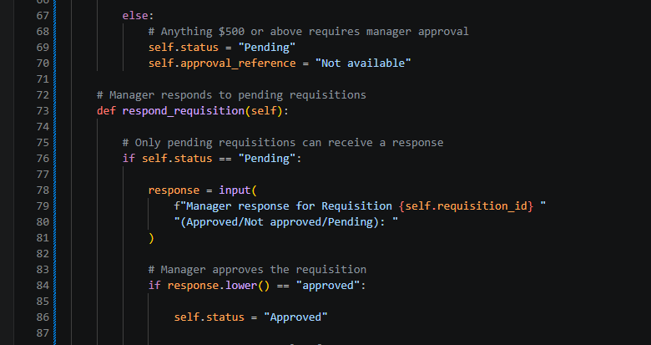

During the implementation phase, there were also ways to present the information on the requisition. The `display_requisition()` method prints the complete information of a single requisition such as the requisition ID, staff details, total amount, status and approval reference number. The `display_all_requisitions()` method will call the `display_requisition()` method for each object in the `all_requisitions` array. This design will not have duplicated code since the logic for how to display the data is only written once. 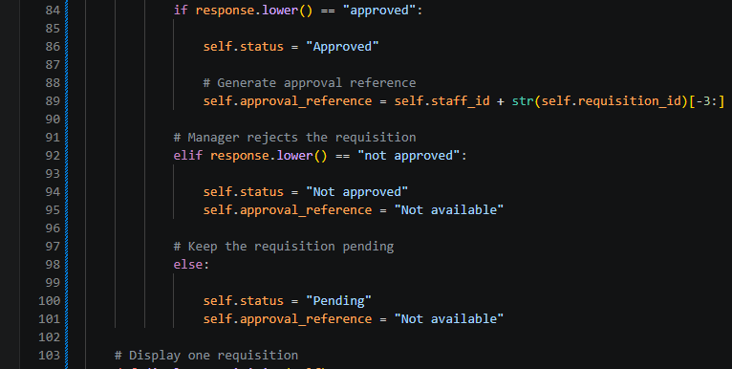

Lastly, I made the requisition_statistics() method available to get some helpful statistics for management. This approach is used to calculate the number of approved, pending and rejected requisitions, before presenting a summary report. The `main()` function manages the flow of the application by creating the necessary requisitions, handling the responses from the managers, reporting back, and calculating the new statistics.
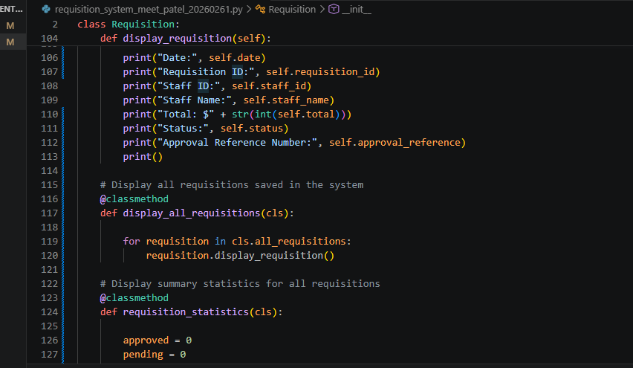
In general, the implementation stage was able to complete the planned software design into a complete working software. All the methods that are written in this step carry out a particular activity, and the code is easier to read, test, debug and maintain.
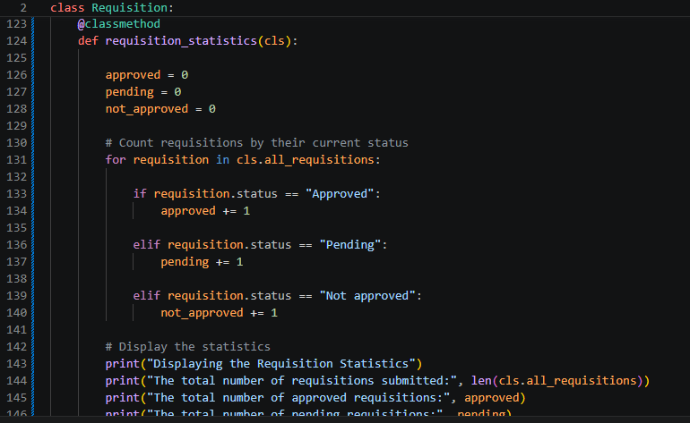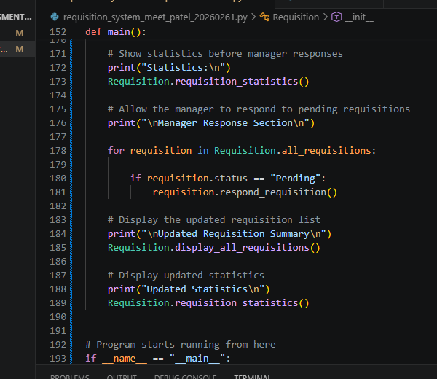

Implementation activities

- Improved the design of Requisition class.
- Implemented the constructor (__init__()).
- Created the `add requisition () method.
- Added automated Approval Logic.
- Drove the development of the manager response function.
- All requisitions that are stored in `all requisitions`.
- Displayed requisition reports.
- Generated statistical reports.
- Properly running programs using the `main()` function.

5. Testing
Once the Implementation stage was over, the next stage of the Software Development Life Cycle was the Testing stage. Testing is one of the most crucial stages as it helps to ensure that the software works properly, delivers the desired outcomes, and meets all project needs. As I was writing my Requisition System, after I added each method, I was continually testing the application, rather than at the end of development. I was able to find errors early and fix them before they'd impacted other components of the program by using this method.
I tested two features, the making of requisition objects first. I added in the other information to the staff such as staff ID and staff name; these were needed so that the constructor, or initializer `__init__()` correctly initialized all of the attributes. I got confirmation that the new created requisition always received a new created Requisition ID which was generated by the class variable (requisition counter). I also confirmed that each object was added to the list that is part of the class, all requisitions.
The next step in the testing process was to test the method hold `add requisition()`. I added several names of items and prices so that the `while True` loop would keep running until the user typed in "no". Various item prices were fed in to ensure that the line `self. Total += item price` was adding up the amount of the items on the requisition. I also tried out single item and multiple item requisition to make sure the total value was correct in either case.
Several different amounts of requisition were then used in the approval process to test it. Requisitions of less than $500 were tested to ensure that the approval reference number was generated and the status was automatically changed to Approved by the approve requisition() method. Additionally, I was able to make up requisitions that exceeded values of $500 or more, which meant they wouldn't be able to be approved by the manager until they were reviewed.
One of the other significant areas of testing had to do with the `respond requisition()` method. The three that I tried were Approved, Not Approved and Pending. All options have been tested to see if the requisition status changed appropriately and if approval reference numbers are generated appropriately. This verified that the manager approval process was operating as per the business rules that had been defined during planning of the process.
Thoughtfully tested also were the display functions. I verified that the `display requisition()` method is able to display the following information about a requisition for each item: Requisition ID, Date, Staff, Total amount, Status, Approval Reference No. Multiple requisitions were used to test the display_all_requisitions() method to see that all objects stored were displayed properly.
Lastly, I tried out the `requisition statistics()` method, which I had already created several approved, pending and rejected requisitions. The statistical output was checked with the expected output to ensure that the method was able to count the number of requisitions submitted, approved, pending and not approved.
Testing each component separately, then testing the entire system provided greater assurance that the software was reliable and that all the assessment needs were met.
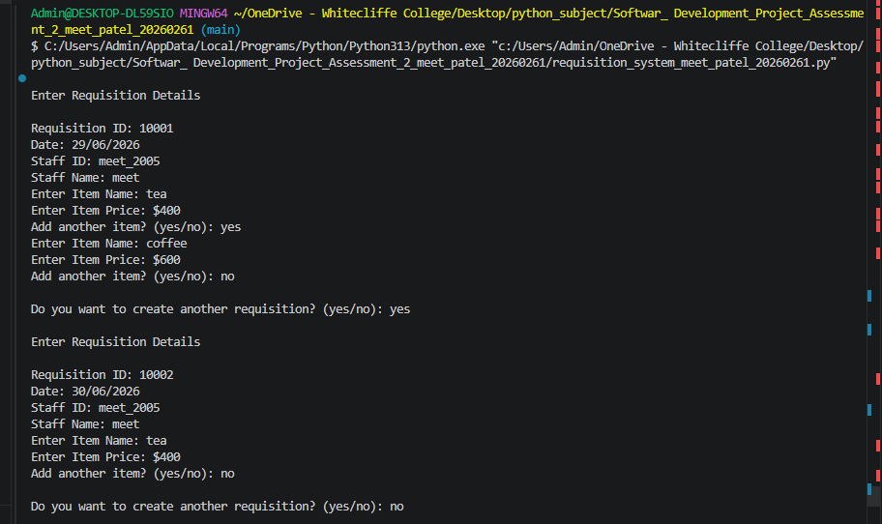
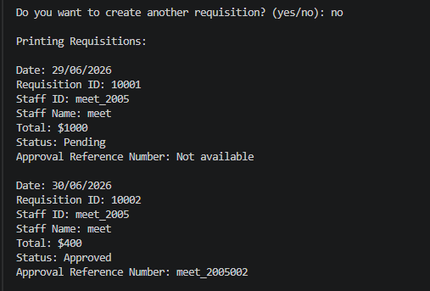
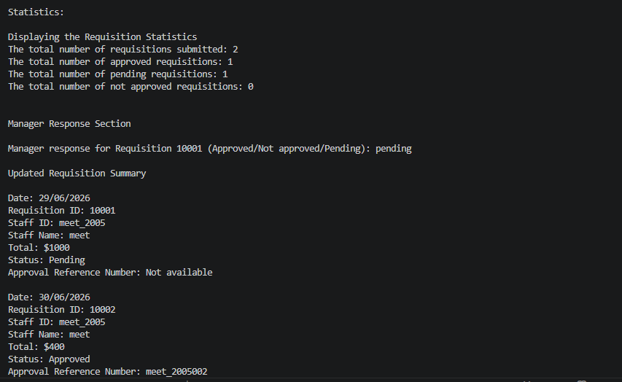
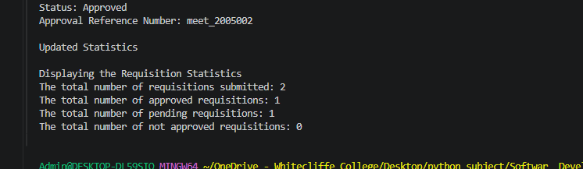

Testing activities completed
- Tested using constructor how to create objects.
- prior to this, it was necessary to manually generate the requisition IDs.
- Tested the ability to enter multiple items of requisition.
- Automatic total calculation (checked).
- Automatic Approval for requisitions under $500 has been tested.
- Reviewed pending for requisitions of $500 and above.
- Tested manager responses – Approved, Not Approved, Pending).
- Created a valid approval reference number.
- Added or subtracted individual and multiple requisitions and tested.
- Confirmed all statistical calculations for all requisitions that are in status.

6. Maintenance
Software Development Life Cycle (SDLC) last stage is Maintenance. The project is over, but maintenance will keep software working after deployment and enhance it for additional needs. Most of my maintenance efforts during the development of my Requisition System were geared towards fixing programming bugs, tidying up the code and making the program easier to read and maintain.
During the program development, I had to face some different types of programming errors in implementing the program. Some of these examples were: Name Error, Attribute Error, wrong variable names, wrong method names, missing object reference, and missing attribute name. The number of errors detected with the use of the traceback in the terminal for each error has been mentioned. The traceback told me on which line it was and I was able to quickly find and fix the problem.
For instance, when I found that variables were used instead of attributes of an object, I fixed it. Missed using the keyword `self` in accessing instance variables, causing runtime errors, in several cases. Additionally, I fixed some spelling errors in attribute names and method names so that each object would access the proper data. Each correction was followed by a re-run of the program and retesting of the problem cases in question to ensure that the problem was being resolved.
Another significant maintenance activity was to make the program more readable. I included comments throughout the code in a meaningful way to explain the use of each class, method and important statement. Such commentaries make it easier for other developers to read and understand the code, and can make the future maintenance simpler.
The application is also designed in a modular way, which will facilitate future maintenance. Each method has one sole responsibility and modifications are possible in one method without impacting the other parts of the application. For instance, if the approval limit changes from $500 to some other number, then only the approve requisition() method has to be changed. Likewise, should more information be gathered from staff, only the constructor will need to be updated.
The current application would meet the assessment requirements but there are a number of enhancements that could be made in the future. Presently the program only stores requisitions in memory during the running of the program. A future version may store requisition information in a database or text file to retain the information after the application exits. Validation of input could also be added to stop the entry of invalid prices and/or blank user input. If the application can be extended to allow for editing or deletion of requisitions, searching by requisition ID etc., as well as export to PDF or Excel, and bring in the graphical user interface (GUI), then it will be more applicable for real world business.
In general, the maintenance phase will ensure that the software will be reliable, adaptable, and easily improved. I have been able to create a program which can be efficiently extended and maintained, by fixing errors and increasing program quality, and finding future improvements.

Maintenance activities completed

- Programming corrections done based on testing.
- Addressed issues with variable, method and attribute names.
- Added comments to improve readability of program.
- After each mark, retested the application.
- Better organization of the code by modular approaches.
- Determined some future improvements for the application.

Future Improvements
- Maintain data for requisitions in a data base.
- Export requisitions in text or CSV file.
- Add input validation for all the user inputs.
- Edit and delete requisitions.
- Add a search functionality by using the requisition ID.
- Include Reporting Options to export reports to PDF or Excel.
- Create graphical user interface (GUI).
- Add user authentication / login capabilities.
Conclusion
The Software Development Life Cycle helped me to build the Requisition System in an organized and structured way. The work done at each stage was helpful in overall successful completion of the project. During planning, the objectives and workflow for the project were determined, the requirements were analyzed to identify what was required in terms of input, processing, and output, the solution design was used to organize the application by using Object-Oriented Programming, implementation took the design and translated it into working Python code, testing was done to ensure that each function worked as intended, and maintenance was performed to fix any bugs and enhance the software.
Through the use of each SDLC stage I was able to develop a functional system to assess a requisition management system suitable for the assessment. The project also enhanced my proficiency in knowing Python programming, object-oriented software development, testing, debugging, version control and professional software development. The application's design is modular, allowing for easy maintenance and extension, ensuring its long-term viability.

A general description of the code for the Requisition System.

This Requisition System has been implemented in Python with Object-Oriented Programming. The program is structured by class to handle the information from the requisition in an organized manner. All of the information and actions for each requisition are stored within the class `Requisition`, which is an object created in each request. The advantage of this is that it helps to maintain the structure of the program, prevent redundant code and simplify the system of understanding, testing and maintenance.

Class Declaration
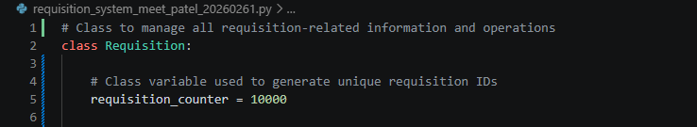
The line defines a new class, called Requisition. A class is used as a blueprint for creating objects. In this program, an object of class `Requisition` is used to represent each requisition request. This approach is effective because all of the information and actions related to the requisition are collected in one location.

It is a class variable that can be used to create a unique requisition ID. It begins at “10000”, and each additional requisition adds one to this number. This is helpful since each and every requisition requires its own ID for identification and tracking.
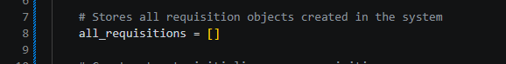
A class variable containing all requisition objects created during the program. A list is utilized because the program can make several requisitions. This allows all requisitions to be displayed and statistics easily calculated at a later time.
Constructor Method
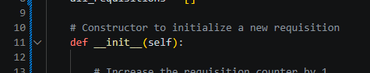
The `__init__()` method is the constructor. It automatically executes when a new requisition object is created. This is good since it gets the necessary information in the beginning of every requisition.
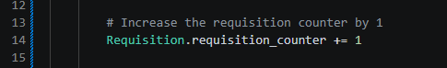
This line is used to increment the requisition count each time a new requisition is created. It automatically generates a unique ID without requiring user input.
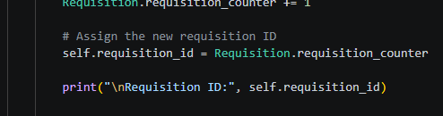
This sets the new value of the counter on the object that is currently being requested. If you use self, the value is associated with the particular requisition that's being created.

This shows the user the new requisition ID. It is useful for the user to see what requisition he or she is typing in.
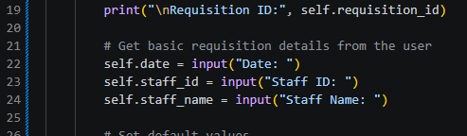
These lines take the basic information about the requisition from the user. The date is the date of the request, the staff ID is the staff member and the staff name is the name of the staff member who made the request.
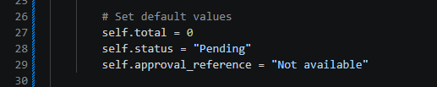
These lines are used to assign default values to the requisition. The total begins at zero since no items have been entered. The status starts as `Pending` until the approval rule is applied. Approval reference will be set to `Not available` as it should only be created when a requisition is approved.

Add Requisition Method

This way, you can add items to the requisition. It is broken out into a separate method as it's a big part of the system.
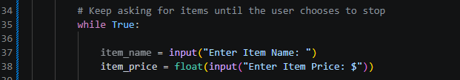
This loop continues to prompt the user to enter items until they want to exit. It is effective since a requisition can have more than a single thing.

These lines are for getting user information of the items. The field name will give the name of the item, and the item price is converted to a float to be used in calculations.

This increases the total amount of the requisition by the amount of the item price. The total will be automatically calculated each time a new item is added.
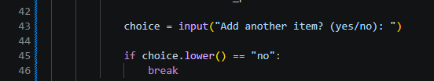
Asks the user if they wish to add more items. It provides the user with options as to how many items to include in the requisition.

This condition will test whether the user entered 'no'. Using the .lower method would cause No, NO and no to be interpreted as the same thing. The `break` statement stops the loop.
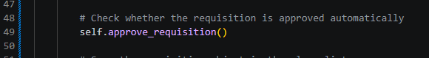
Once all items have been entered, this line calls the approval method. Checks automatically if the requisition should be approved or be left pending.
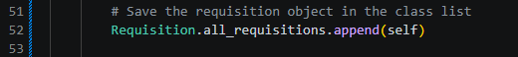
It saves the requisition object which is being displayed at that moment in the class list. This is important because this program will be required to display and count all requisitions later.

This will return the total amount that has been requisitioned. Returning the total will make the method more useful as it can be reused if necessary.
Approval Method
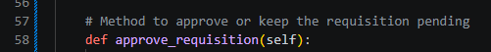
The approach used to determine if a requisition must be automatically approved or is a pending requisition. It is separated from the approval logic, making the code cleaner.
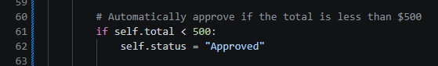
This ensures that sum is below $500. This is the business rule used in the system.

If the total is less than $500 then the status is set to Approved.
This forms an approval reference number, based on the staff ID and the last 3 digits of the requisition ID. This is helpful as approved requisitions require a reference number to be tracked.
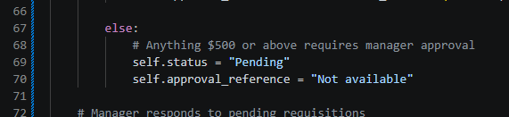
If the total is `$500 or greater`, the requisition is pending. The approval reference will not be created as manager approval is pending.
Manager Response Method
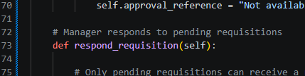
This way, the manager can respond to the pending requisitions.
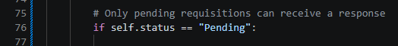
This way, only pending requisitions will be visible to the manager. For approved requisitions, there is no Manager Response required.
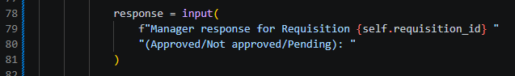
This will prompt the manager to type in a response, Approved, Not approved, or Pending.
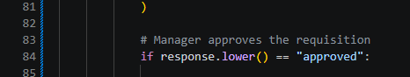
This tests if the requisition was approved by the manager.
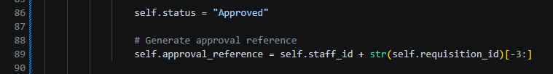
Once approved, the status is marked and a reference number is provided for the approval.
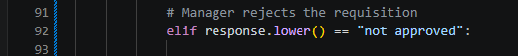
This is the test for determining if the manager denied the requisition.
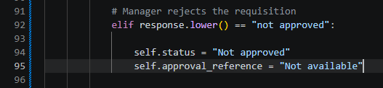
The status changes to `Not approved` if it is rejected, and no approval reference will be created.

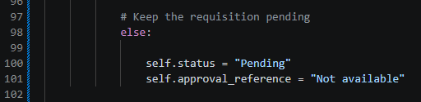
Any other response by the manager leaves the requisition pending. This leaves the request pending for review later.

Display Requisition Method
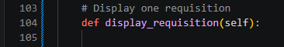
This method shows the information about a single requisition. It aids in presenting information to the user in a clear way.
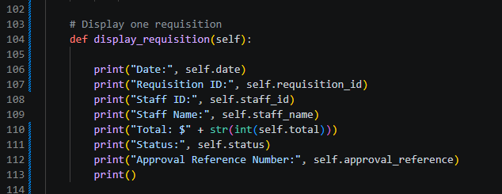
All important details of a requisition are printed out. The total is rounded to an integer so that it can be displayed as a simple number.
This method is used to display all the Requisitions. All Requisitions are displayed using this method.
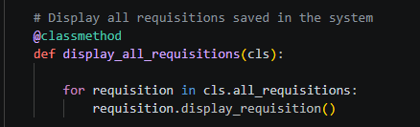
This is a class method, that is, it operates on the class list `all_requisitions`, rather than on a single object.

This loop prints out each of the requisition elements in the list. Reuses the method display_requisition() so it doesn't repeat code.
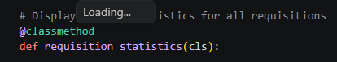
This provides summary statistics for all requisitions and will display these.
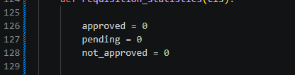
These variables represent the number of requests which have been accepted, in progress and rejected.
This loop inspects all the required ones in the system.
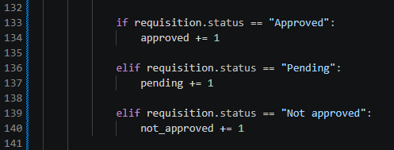
These conditions monitor the status for each requisition and update the appropriate counter.
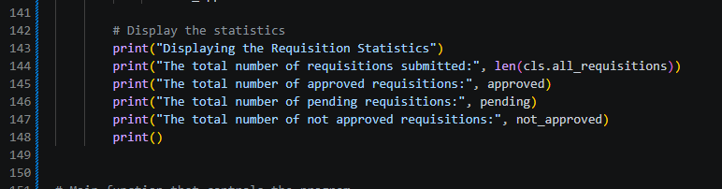
This prints the total number of requisitions by using the length of the list.
Main Function
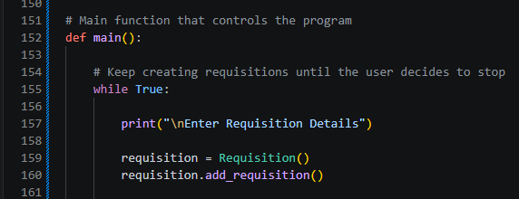
The whole program is directed by the function called `main()`.
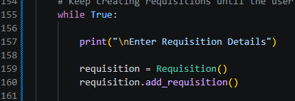
This loop can be used to make several requisitions.
These lines will make the new requisition object and invoke the method to add items.
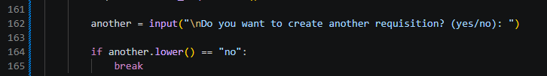
This questions the user to create another requisition?

This prevents user from continuing to add requisitions if they do not wish to add further requisitions.
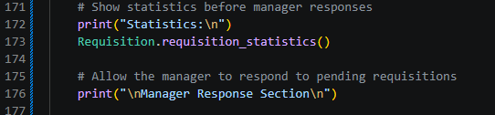
These are all the requisitions and statistics before manager responses.
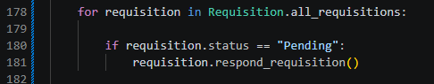
This loop will compare all requisitions, and only the manager will be able to reply to pending ones.
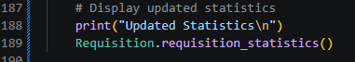
These lines are the updated requisition summary and updated statistics after the manager answers the requisition.
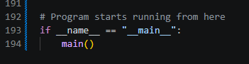
This is the place to enter the program. It makes sure that the function `main()` will be called only when the file is run as the program.

Conclusion
The code is effective overall in organizing the requirement system clearly using Object Oriented Programming. Program is structured and easy to maintain using classes, objects, methods, class variables, loops and conditions. Each method has a clear purpose, which follows good software design principles such as single responsibility and separation of concerns. The system can generate requisitions, can sum them and its totals, can apply approval rules, can process manager responses, displays information and generates statistics, all successfully.

